### 

**NAME:** Neev Shah

**USN:** 22BTRCL107

**CLASS:** AIML-C

**DATE:** 24th April 2024

# 

# **ASSIGNMENT on JOINS**

**For following practice sets, use Online SQL editor provided by W3Schools.**

**It already has a database with 8 tables. Also, There are sufficient records in each table.**

**Develop queries for following tasks while executing them on this database itself.**

**Please keep all the queries saved in a txt file for uploading your assignment purposes.**

**To complete following tasks, use only your understanding of SQL and JOINS. You can take little help in syntax from internet, but try to avoid using Gen-AI products like ChatGPT to complete the tasks.**

**Task 1: List out all the orders with customers.**

SELECT Orders.OrderID, Orders.OrderDate, Customers.CustomerName

FROM Orders

INNER JOIN Customers ON Orders.CustomerID = Customers.

**Task 2: List out all the orders with customers and employees.**

SELECT Orders.OrderID, Orders.OrderDate, Customers.CustomerName

FROM Orders

INNER JOIN Customers ON Orders.CustomerID = Customers.CustomerID;

SELECT Orders.OrderID, Orders.OrderDate, Employees.FirstName, Employees.LastName

FROM Orders

INNER JOIN Employees ON Orders.EmployeeID = Employees.EmployeeID;

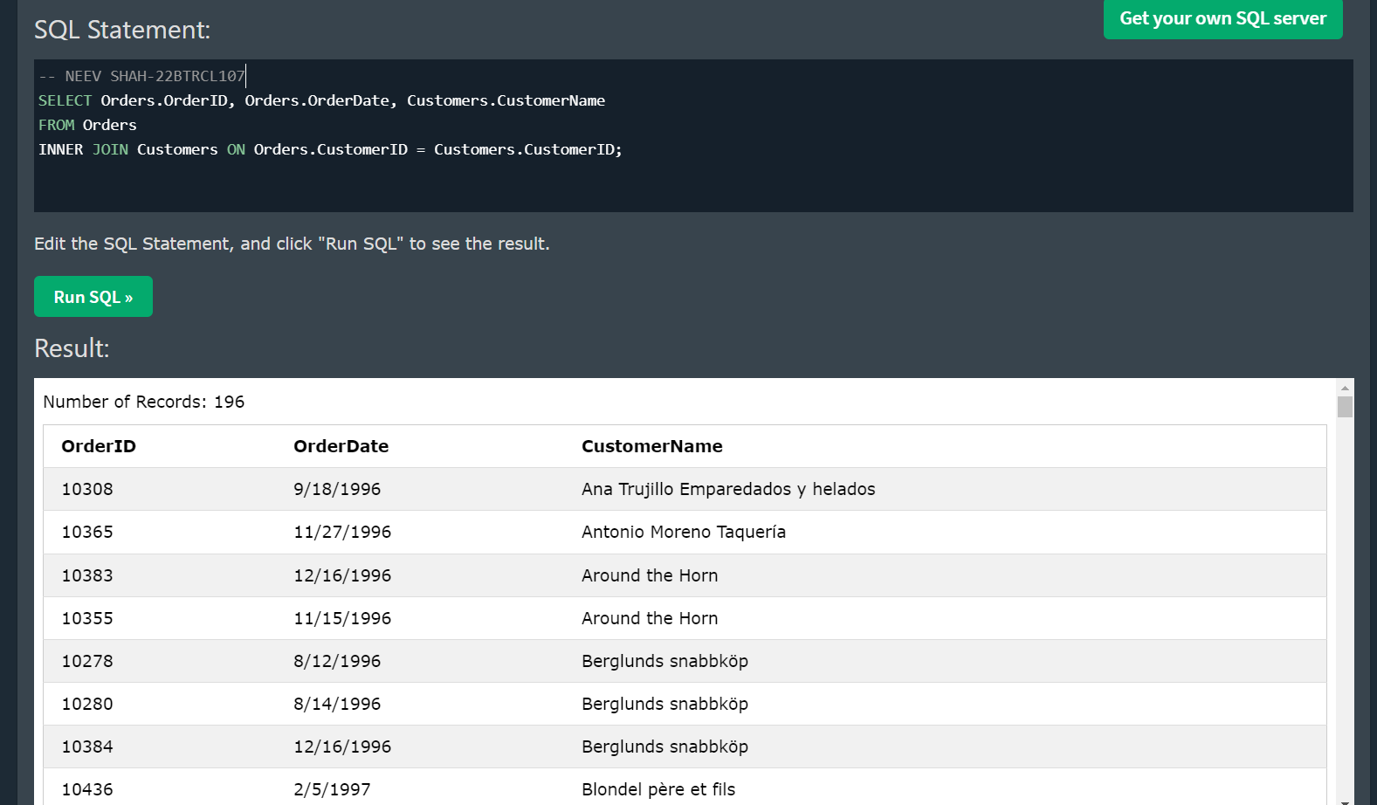

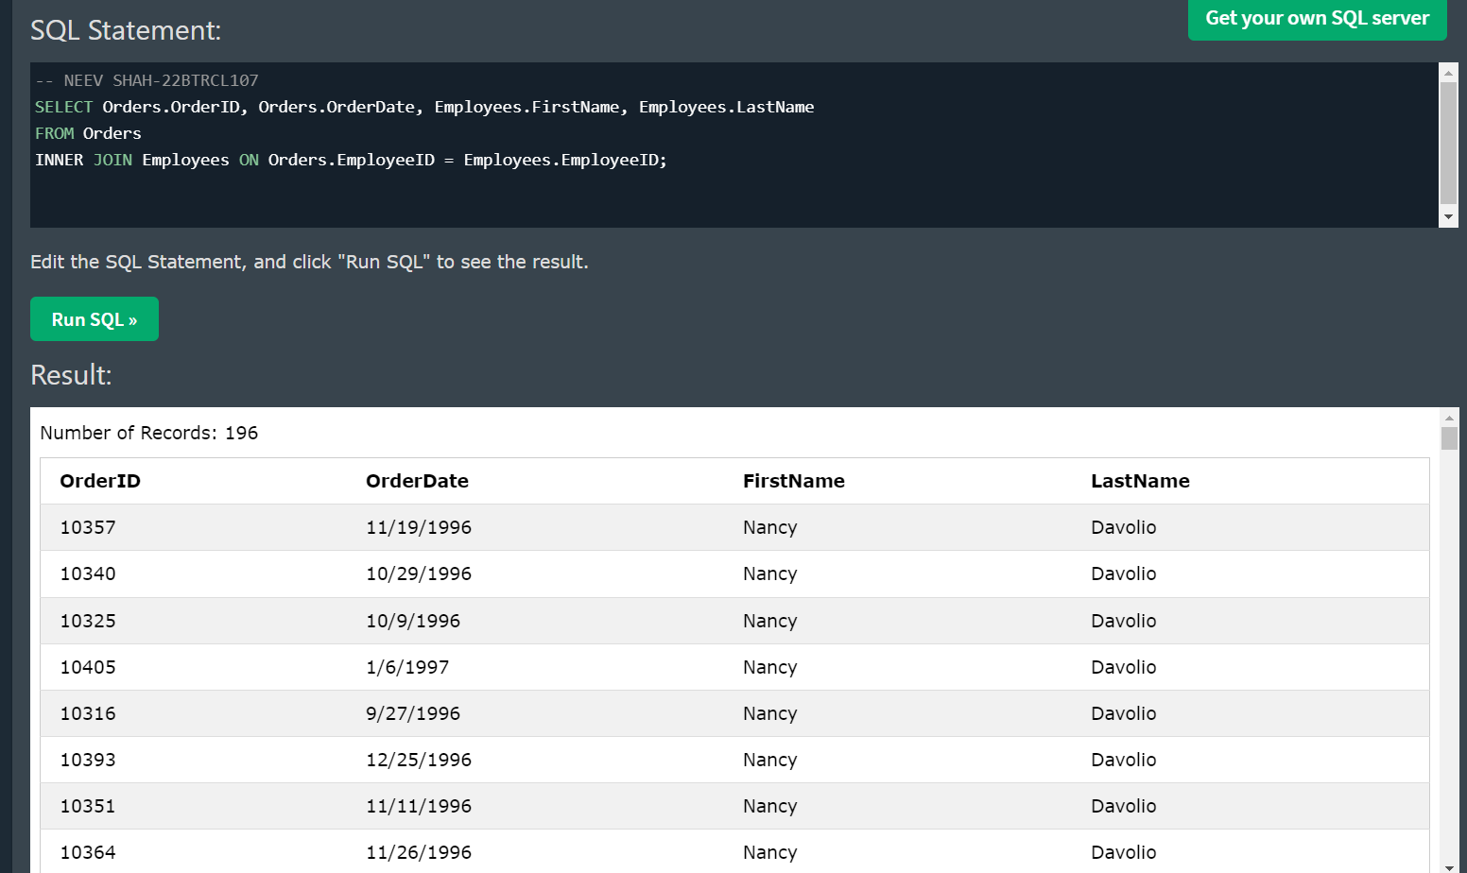

**Task 3: List out all the products with their categories.**

SELECT Products.ProductID, Products.ProductName, Categories.CategoryName

FROM Products

INNER JOIN Categories ON Products.CategoryID = Categories.CategoryID;

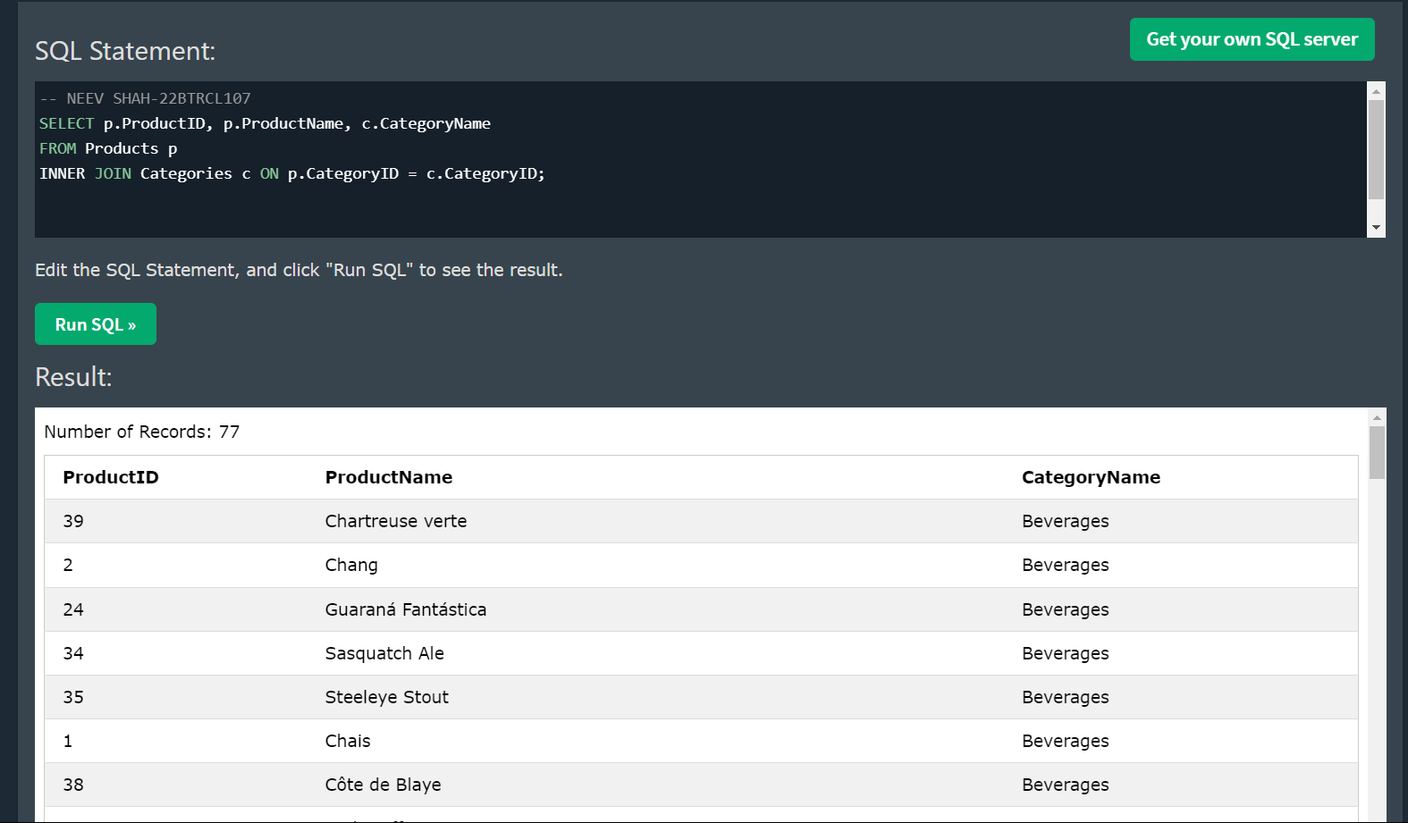

**Task 4: List out all the orders with shipping details.**

SELECT Orders.OrderID, Orders.OrderDate, Shippers.ShipperName

FROM Orders

INNER JOIN Shippers ON Orders.ShipperID = Shippers.ShipperID;

SELECT Orders.OrderID, Orders.OrderDate, Customers.CustomerName

FROM Orders

INNER JOIN Customers ON Orders.CustomerID = Customers.CustomerID;

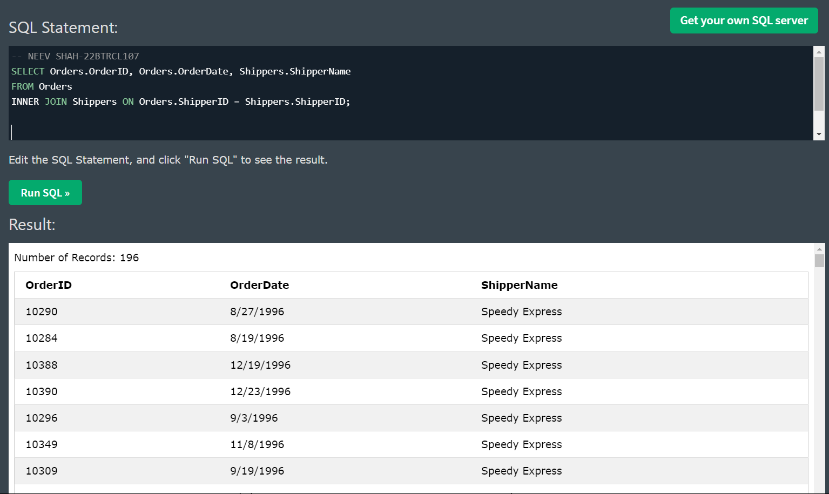

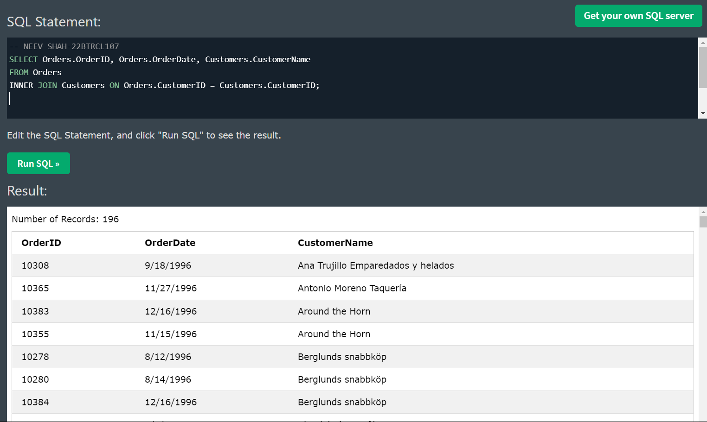

**Task 5: List out all the employees who have not placed any orders.**

SELECT e.EmployeeID,e.FirstName, e.LastName

FROM Employees e

LEFT JOIN Orders o ON e.EmployeeID = o.EmployeeID

WHERE o.OrderID IS NULL;

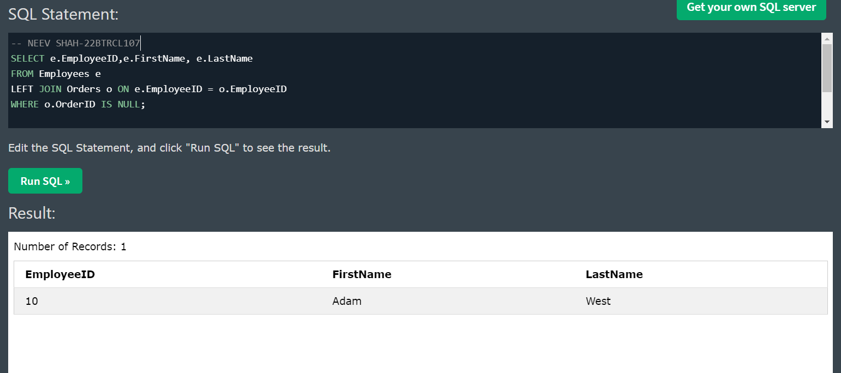

**Task 6: List out top 5 products by order quantity.**

SELECT Products.ProductId, ProductName, sum(OrderDetails.Quantity) as Total_quantity

FROM Products

INNER Join OrderDetails on Products.ProductID = OrderDetails.ProductID

group by Products.ProductId, Products.ProductName

order by sum(OrderDetails.Quantity) desc;

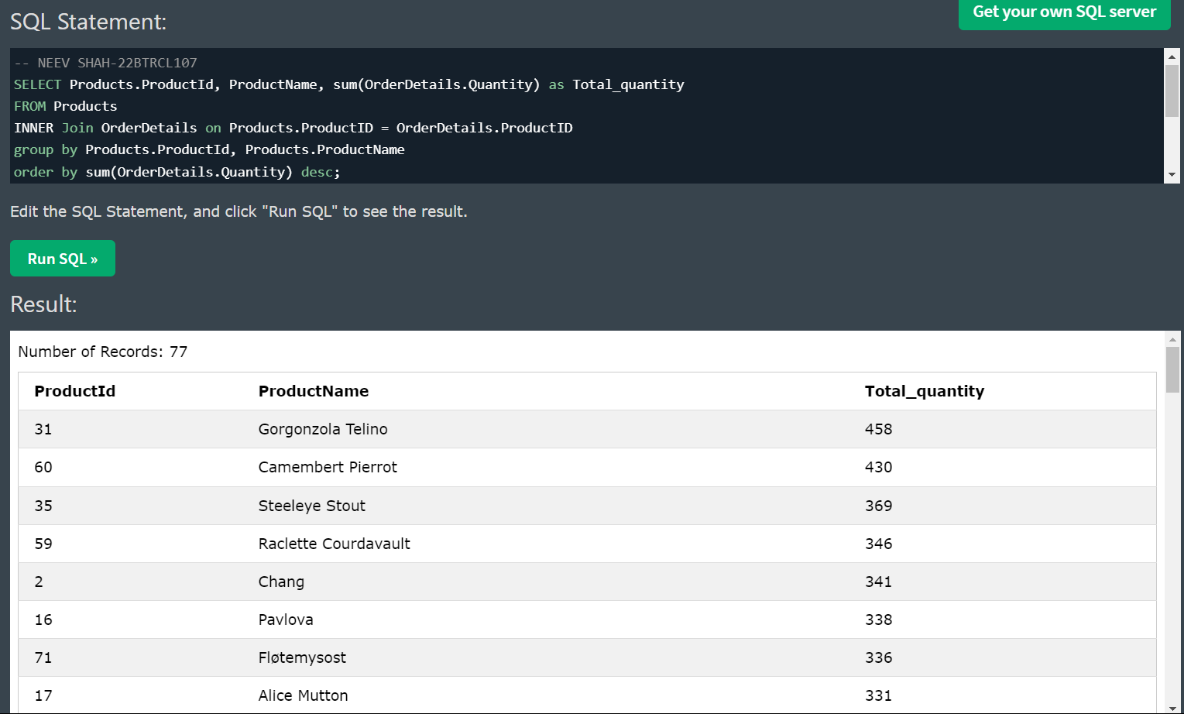

**Task 7: List out customers and their orders in 2023 only.**

SELECT Customers.CustomerName, Orders.OrderID, Orders.OrderDate

FROM Orders

INNER JOIN Customers ON Orders.CustomerID = Customers.CustomerID

WHERE YEAR(Orders.OrderDate) = 2023;

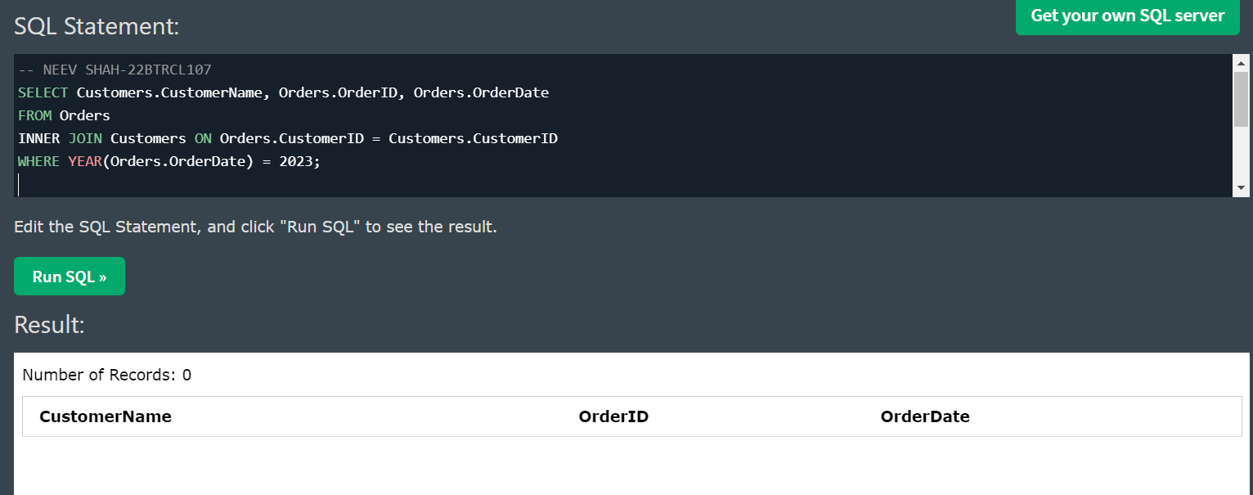

**Task 8: List out all the suppliers with their products.**

SELECT Suppliers.SupplierName, Products.ProductName

FROM Suppliers

INNER JOIN Products ON Suppliers.SupplierID = Products.SupplierID;

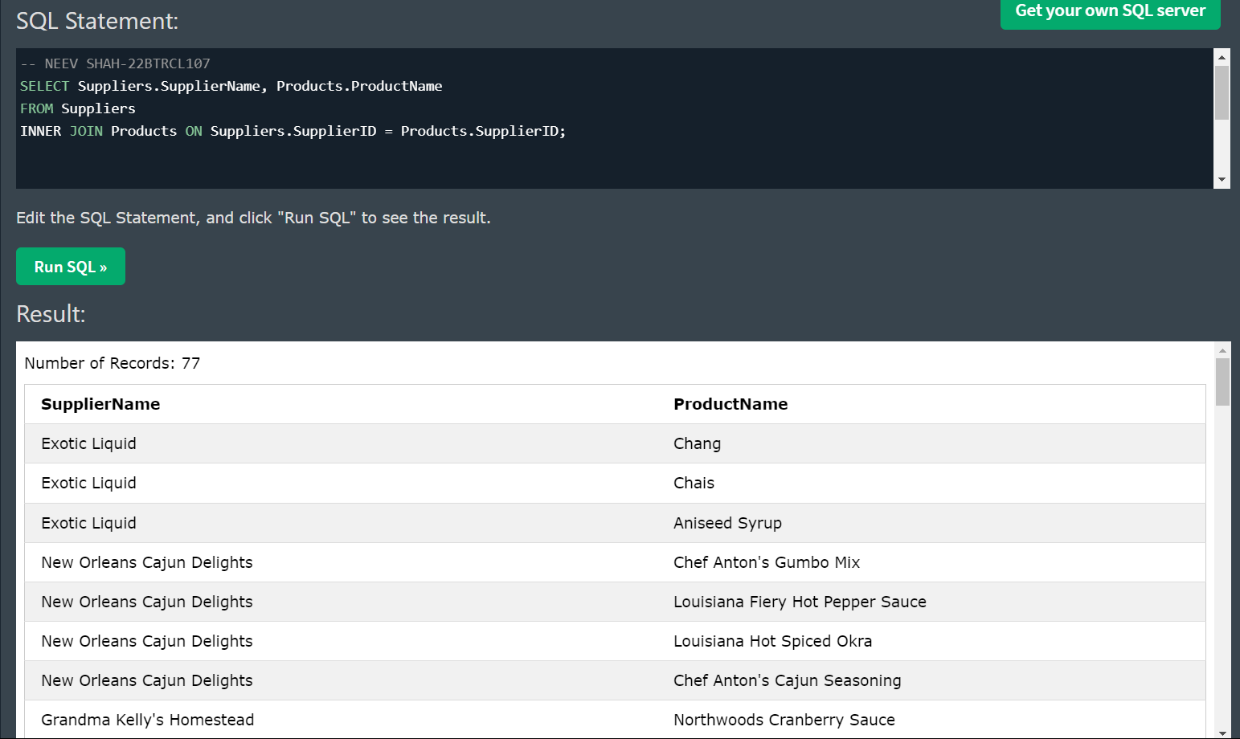

**Task 9: List out all the orders with their detailed product information.**

SELECT Orders.OrderID, OrderDetails.Quantity

FROM OrderDetails

INNER JOIN Orders ON OrderDetails.OrderID = Orders.OrderID;

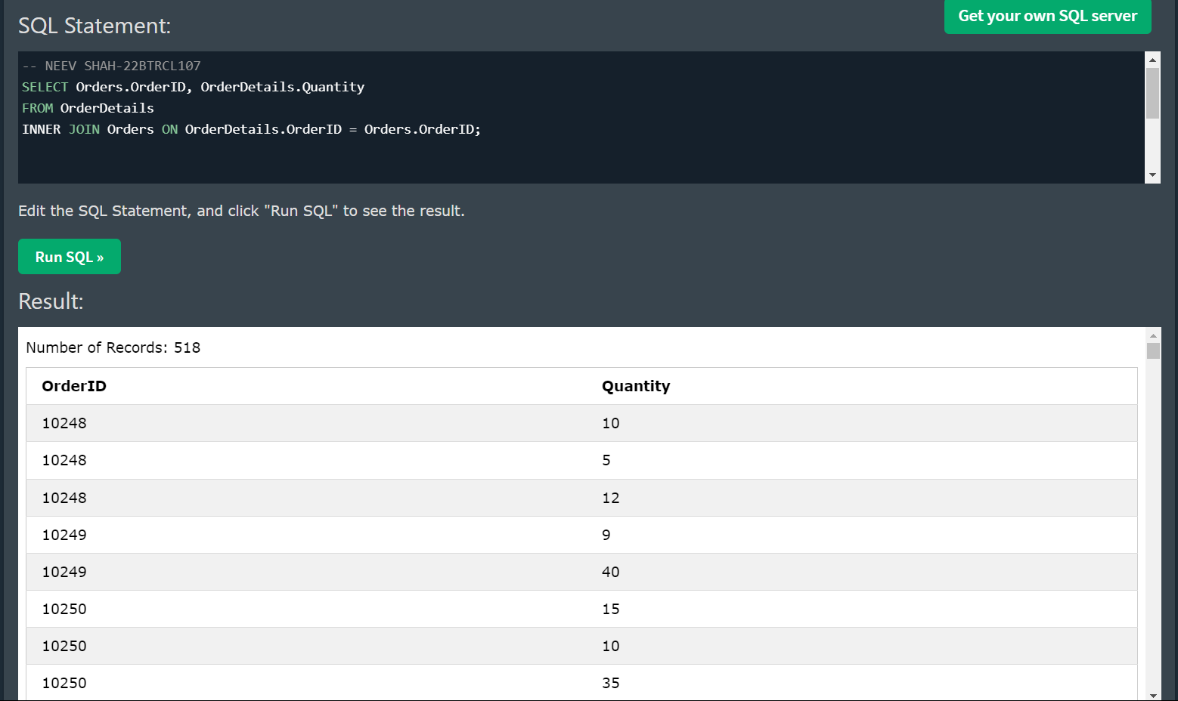

**Challenge: Find birthdays in same month.**

SELECT E1.FirstName AS name_1, E2.FirstName AS name_2, MONTH(E1.BirthDate) AS birth_month

FROM Employees E1, Employees E2

WHERE E1.EmployeeID < E2.EmployeeID

AND MONTH(E1.BirthDate)=MONTH(E2.BirthDate)

ORDER BY MONTH(E1.BirthDate), E1.EmployeeID;

